# What are the social outcomes of climate policies?

Protocol for a systematic map

## Scope

* We aim to identify the social outcomes of climate policies, as assessed in ex-post studies of implemented measures.
* An ex-post study is one that examines already implemented policies. We have no methodological restrictions for the type of study (quantitative, modelling, qualitative), however:
  + Scenarios of possible, not implemented, policies are excluded
  + Scenarios and assessments of proposed, not implemented, policies are excluded
* All climate policy measures that penalise fossil fuel use or reduce energy demand are considered, with the following conditions:
  + These are implemented by political (not private) institutions at a national, regional or urban scale (voluntary and corporate initiatives are excluded)
  + Measures on land (i.e. agriculture, forestry) are excluded
  + Climate adaptation policies are excluded
* Social outcomes broadly encompass the Sustainable Development Goals (see Figure 1), with two key exceptions
  + Health impacts are excluded (air quality, benefits of active travel, etc.)
  + Generic economic growth outcomes are excluded (e.g. social cost of carbon, ‘welfare’ impacts)

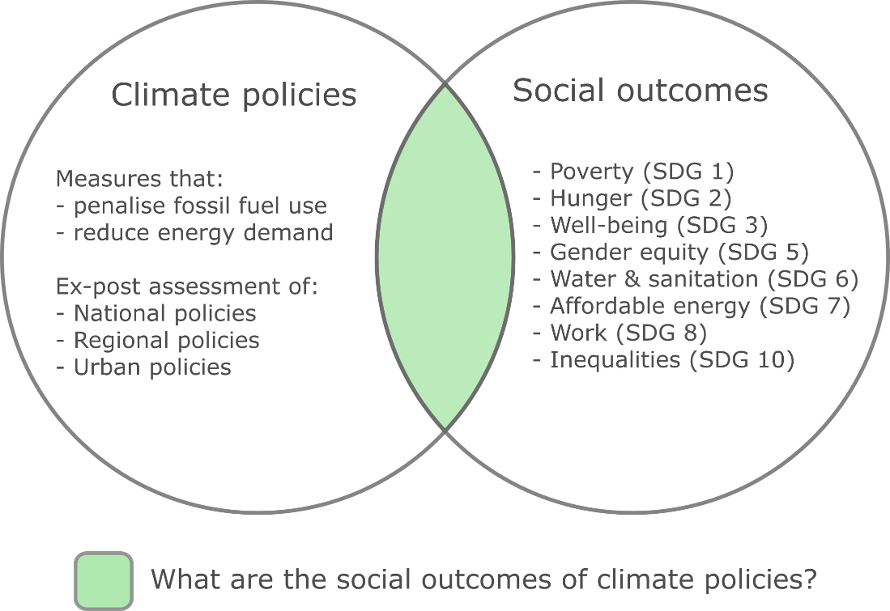

Figure 1: Scope of study

|  |  |  |
| --- | --- | --- |
|  | **Inclusion** | **Exclusion** |
| **Ex-post** | * Studies on actual implemented policies – modelling, qualitative assessments, etc. | * Studies on policies not yet implemented * Simulations of possible policies * **Ex-ante analysis of ex-post policies** |
| **Intervention type** | * Supports low/zero-carbon/energy demand reducing technologies and actions * Penalizes fossil fuel and high energy use | * Land-use sector (agriculture, forestry, also migration) [also disqualifies biofuels] * Adaptation & climate impacts * Measures directed at local air pollution (e.g. NOx, SOx only) * Social policies with climate outcomes (e.g. social housing) * **Energy price fluctuations with no policy intervention** * Fuel switching (e.g. biomass -> LPG) |
| **Outcome type** | * Poverty and livelihoods * Nutrition and hunger * Well-being and basic needs * Equity and gender * Infrastructure access (water, sanitation, electricity) * Energy services access and mobility * Jobs and unemployment * Inequality and distribution * Housing and shelter * Air quality | * Non-air quality related health * GDP, “Social cost of carbon” (aggregate economic measures) |
| **Scope of study** | * Has a statement of climate/energy policy   Led by political institutions:   * National * Regional * Urban or local * Program based   Population sample:   * Individuals, households, social groups (gendered, classed) | Let by private institutions   * Voluntary initiatives * Corporate social responsibility   Population sample:   * Industries, sectors, companies |

Table 1: Summary of inclusion and exclusion criteria

## Literature Search

* Due to the broad scope of possible interventions and outcomes, and high number of possible search hits, the general approach is to conduct separate title and abstract searches and use detailed exclusion criteria in each (see Figure 3).
* In the title search, we include a large number of possible intervention and outcome terms (see Figure 4). Based on a manual assessment of the results, and using topic modelling, we then apply a set of subject category and keyword based exclusions.
* In the abstract/title search, we include the same set of intervention and outcome terms, but then apply a further set of effect terms (see Figure 5). In addition we use a NEAR/3 operator to increase the accuracy of the intervention terms. As a further exclusion criteria, we use a python script to reject any documents that *do not* refer to a country, region or city in the title or abstract.

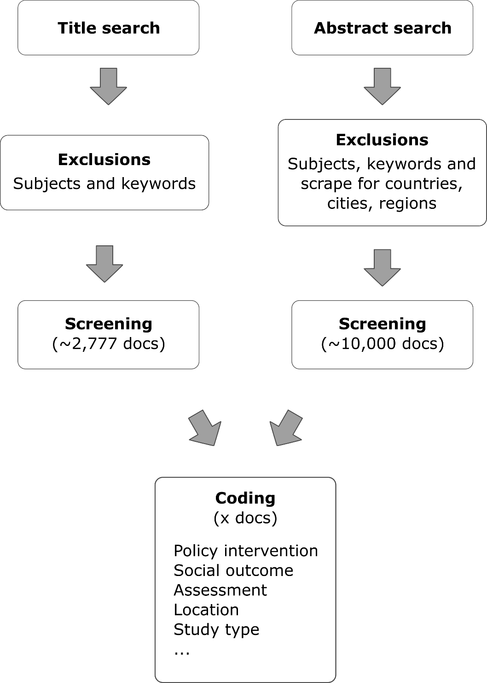

**Figure 3: General approach**

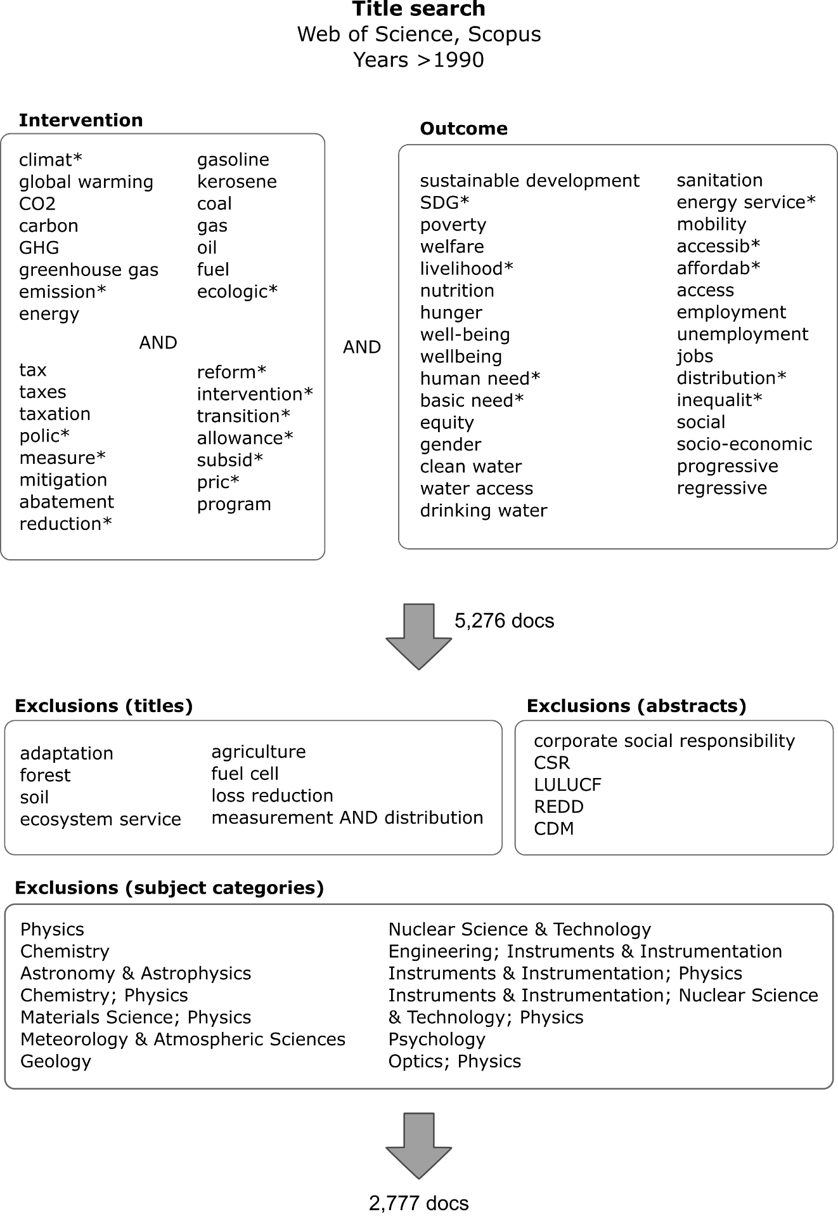

**Figure 4: Title search terms and exclusions**

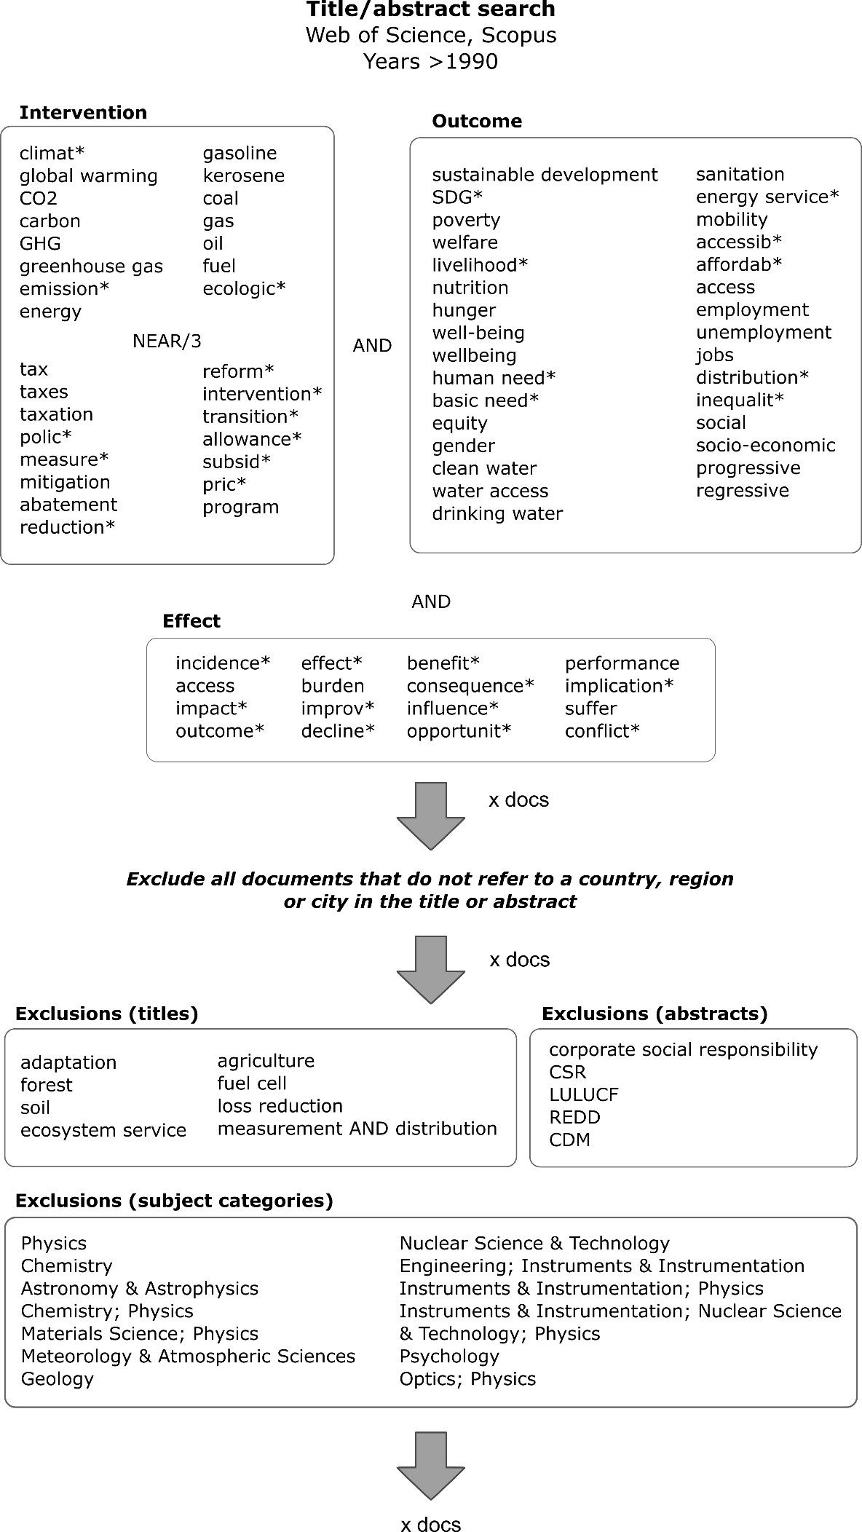

**Figure 5: Title/abstract search terms and exclusions**

## Literature Screening

* A sample of articles will be allocated to authors prior to full screening, in order to check for coding consistency. We will do this using the ‘APSIS Scoping Platform’ developed at MCC.
* Once a high consistency and detailed screening criteria have been developed, the remaining articles will be independently screened by authors.

Results

1st round of 100 articles (Will, Kilian, Mike, Finn): 0.67

## Literature Coding

* The primary information to code will be the type of intervention (policy), analysed outcome (social effect), and population (e.g. location, country)
* Secondary information includes the effect type (positive, negative), study type (quantitative, qualitative) and identified barriers/constraints to positive outcomes
* We will allocate a sample of articles to authors for coding, again to check for consistency and identify the appropriate categories. These will then be scaled up and independently coded by authors.

## Analysis

* We will report the coded information, focusing types of policies, outcomes, and intervention locations
* We will also analyse the literature development as a whole, e.g. time trends, epistemic communities (e.g. using bibliometric information), topic analysis (using topic modelling).